1. Bukalah tugas kalian ([📄12. Soal Assets, Dialog Bottomsheet, Navigation](https://cobalt-bike-c9e.notion.site/12-Soal-Assets-Dialog-Bottomsheet-Navigation-b0ce043cec734de0adb835ee185c9850) )
2. Tambahkan & Implementasikan penggunaan provider pada aplikasi tersebut

1). Flutter Code:

* GridviewModel.dart

class GridviewModel {

String title;

String image;

GridviewModel({required this.title, required this.image});

}

* GridviewProvider.dart

import 'package:flutter/material.dart';

import 'package:flutter_platform_widget/Assets-Dialog-Bottomsheet-Navigation/GridviewModel.dart';

class GridviewProvider with ChangeNotifier {

List<GridviewModel> _gridView = [];

List<GridviewModel> get gridView => _gridView;

void addImage(GridviewModel gridView) {

_gridView.add(gridView);

print(_gridView.length);

notifyListeners();

}

void deleteImage(int index) {

_gridView.removeAt(index);

notifyListeners();

}

void updateImage(int index, GridviewModel gridview) {

_gridView[index] = gridview;

notifyListeners();

}

}

* ImageGridview.dart

import 'package:flutter/material.dart';

import 'package:flutter_platform_widget/Assets-Dialog-Bottomsheet-Navigation/GridviewModel.dart';

import 'package:flutter_platform_widget/Assets-Dialog-Bottomsheet-Navigation/GridviewProvider.dart';

import 'package:flutter_platform_widget/Assets-Dialog-Bottomsheet-Navigation/ShowImagePage.dart';

import 'package:provider/provider.dart';

class ImageGridview extends StatelessWidget {

void showImage(BuildContext context, String imagePath) {

Navigator.push(

context,

MaterialPageRoute(builder: (_) => ShowImagePage(imagePath: imagePath)),

);

}

@override

Widget build(BuildContext context) {

return Consumer<GridviewProvider>(

builder: (context, GridviewProvider, child) {

return GridView.builder(

gridDelegate: const SliverGridDelegateWithFixedCrossAxisCount(

crossAxisCount: 2,

crossAxisSpacing: 8,

mainAxisSpacing: 8,

),

itemBuilder: (context, index) {

GridviewModel gridviewModel = GridviewProvider.gridView[index];

return GestureDetector(

onTap: () {

showModalBottomSheet(

context: context,

builder: (BuildContext context) {

return Container(

margin: const EdgeInsets.only(top: 10),

height: 500,

child: Column(

children: [

const Center(

child: Text('Tampilkan Gambar ?'),

),

const SizedBox(

height: 30,

),

SizedBox(

height: 300,

child: Image.network(

GridviewProvider.gridView[index].image,

fit: BoxFit.cover,

)),

const SizedBox(

height: 10,

),

Row(

children: [

TextButton(

onPressed: () {

showImage(

context,

GridviewProvider

.gridView[index].image);

},

child: const Text('Ya'),

),

TextButton(

onPressed: () {

Navigator.of(context).pop();

},

child: const Text('Tidak'),

),

],

)

],

),

);

});

},

child: Card(

shape: RoundedRectangleBorder(

borderRadius: BorderRadius.circular(20)),

color: Colors.white,

child: Stack(

children: [

SizedBox(

width: 140,

height: 140,

child: Image.network(

GridviewProvider.gridView[index].image,

fit: BoxFit.fill,

),

),

Positioned(

right: 0,

child: IconButton(

color: Colors.black,

icon: const Icon(Icons.edit),

onPressed: () {

Navigator.pushNamed(context, '/update_image',

arguments: <String, dynamic>{

'index': index.toString(),

});

},

),

),

Positioned(

bottom: 10,

left: 10,

child: Text(

GridviewProvider.gridView[index].title,

style: const TextStyle(color: Colors.black),

),

),

Positioned(

bottom: 0,

right: 0,

child: IconButton(

color: Colors.black,

icon: const Icon(Icons.delete),

onPressed: () {

GridviewProvider.deleteImage(index);

},

))

],

),

),

);

},

itemCount: GridviewProvider.gridView.length);

},

);

}

}

* ImageGridviewPage.dart

import 'package:flutter/material.dart';

import 'package:flutter_platform_widget/Assets-Dialog-Bottomsheet-Navigation/ImageGridview.dart';

import 'package:flutter_platform_widget/Assets-Dialog-Bottomsheet-Navigation/ShowImagePage.dart';

class ImageGridviewPage extends StatelessWidget {

void showImage(BuildContext context, String imagePath) {

Navigator.push(

context,

MaterialPageRoute(builder: (_) => ShowImagePage(imagePath: imagePath)),

);

}

@override

Widget build(BuildContext context) {

return Scaffold(

appBar: AppBar(

title: const Text('Galeri'),

),

body: ImageGridview(),

floatingActionButton: FloatingActionButton(

onPressed: () {

Navigator.pushNamed(context, '/add_image');

},

tooltip: 'Add Item',

child: const Icon(Icons.add),

),

);

}

}

* ShowImagePage.dart

import 'package:flutter/material.dart';

class ShowImagePage extends StatelessWidget {

final String imagePath;

ShowImagePage({required this.imagePath});

@override

Widget build(BuildContext context) {

return Scaffold(

appBar: AppBar(

title: const Text('Image'),

centerTitle: true,

),

body: Center(

child: Image.network(imagePath),

),

);

}

}

* AddImageForm.dart

import 'package:flutter/material.dart';

import 'package:flutter_platform_widget/Assets-Dialog-Bottomsheet-Navigation/GridviewModel.dart';

import 'package:flutter_platform_widget/Assets-Dialog-Bottomsheet-Navigation/GridviewProvider.dart';

import 'package:provider/provider.dart';

class AddImageForm extends StatefulWidget {

const AddImageForm({Key? key}) : super(key: key);

@override

State<AddImageForm> createState() => _AddImageFormState();

}

class _AddImageFormState extends State<AddImageForm> {

final _formKey = GlobalKey<FormState>();

final TextEditingController titleController = TextEditingController();

final TextEditingController imageController = TextEditingController();

@override

Widget build(BuildContext context) {

return Scaffold(

appBar: AppBar(

title: const Text("Add Image"),

centerTitle: true,

),

body: Form(

key: _formKey,

child: Column(

children: [

TextFormField(

controller: titleController,

decoration: const InputDecoration(

labelText: "Title",

),

validator: (value) {

if (value!.isEmpty) {

return 'Please enter title';

}

return null;

},

),

TextFormField(

controller: imageController,

decoration: const InputDecoration(

labelText: "Image Url",

),

validator: (value) {

if (value!.isEmpty) {

return 'Please enter image url';

}

return null;

},

),

TextButton(

onPressed: () {

if (_formKey.currentState!.validate()) {

final provider =

Provider.of<GridviewProvider>(context, listen: false);

provider.addImage(

GridviewModel(

title: titleController.text,

image: imageController.text,

),

);

Navigator.pop(context);

}

},

child: const Text('submit'),

),

],

),

),

);

}

}

* UpdateImageForm.dart

import 'package:flutter/material.dart';

import 'package:flutter_platform_widget/Assets-Dialog-Bottomsheet-Navigation/GridviewModel.dart';

import 'package:flutter_platform_widget/Assets-Dialog-Bottomsheet-Navigation/GridviewProvider.dart';

import 'package:provider/provider.dart';

class UpdateImageForm extends StatefulWidget {

const UpdateImageForm({Key? key}) : super(key: key);

@override

State<UpdateImageForm> createState() => _UpdateImageFormState();

}

class _UpdateImageFormState extends State<UpdateImageForm> {

final _formKey = GlobalKey<FormState>();

final TextEditingController titleController = TextEditingController();

final TextEditingController imageController = TextEditingController();

int? index;

getData() async {

final Map<String, dynamic> data =

ModalRoute.of(context)!.settings.arguments as Map<String, dynamic>;

index = int.parse(data['index']);

GridviewModel gridviewModel =

Provider.of<GridviewProvider>(context, listen: false).gridView[index!];

titleController.text = gridviewModel.title;

imageController.text = gridviewModel.image;

setState(() {});

}

@override

void initState() {

Future.delayed(Duration.zero, () {

getData();

});

super.initState();

}

@override

Widget build(BuildContext context) {

return Scaffold(

appBar: AppBar(

title: const Text("Update Image"),

centerTitle: true,

),

body: Form(

key: _formKey,

child: Column(

children: [

TextFormField(

controller: titleController,

decoration: const InputDecoration(

labelText: "Title",

),

validator: (value) {

if (value!.isEmpty) {

return 'Please enter title';

}

return null;

},

),

TextFormField(

controller: imageController,

decoration: const InputDecoration(

labelText: "Image Url",

),

validator: (value) {

if (value!.isEmpty) {

return 'Please enter image url';

}

return null;

},

),

TextButton(

onPressed: () {

if (_formKey.currentState!.validate()) {

final provider =

Provider.of<GridviewProvider>(context, listen: false);

provider.updateImage(

index!,

GridviewModel(

title: titleController.text,

image: imageController.text),

);

Navigator.pop(context);

}

},

child: const Text('submit'),

),

],

),

),

);

}

}

2). Output:

* Menampilkan galeri dari provider

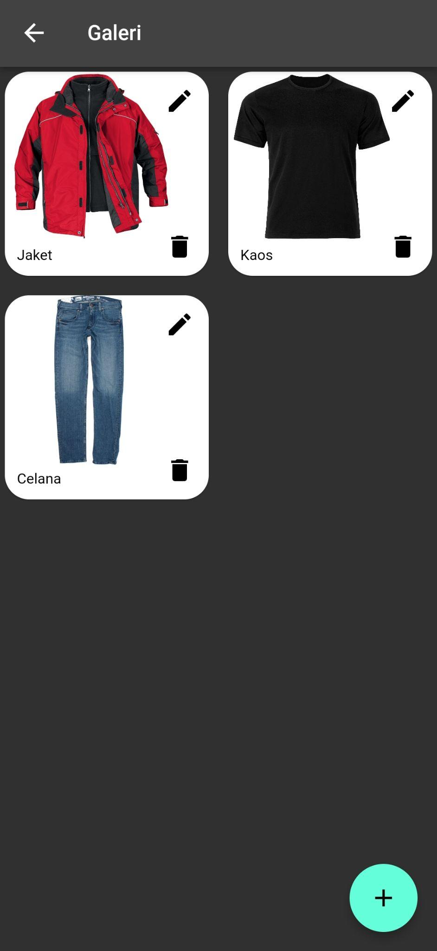

* Menambahkan galeri melalui provider: Untuk menambahkan item galeri menggunakan floating action button yang ada di pojok kanan bawah dari halaman galeri.
  + - Form menambahkan galeri melalui provider

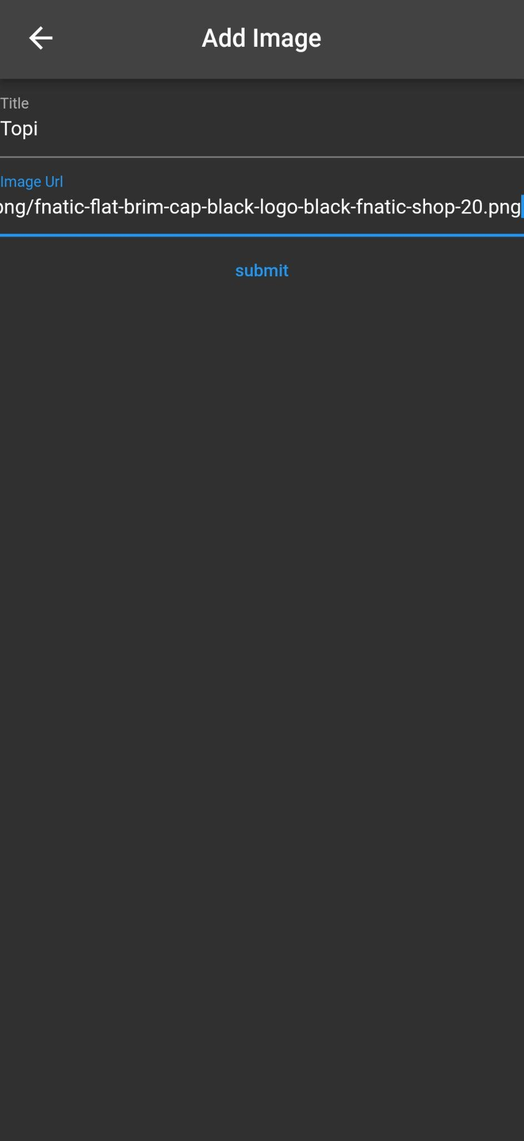

* + - Galeri setelah menambahkan item melalui provider

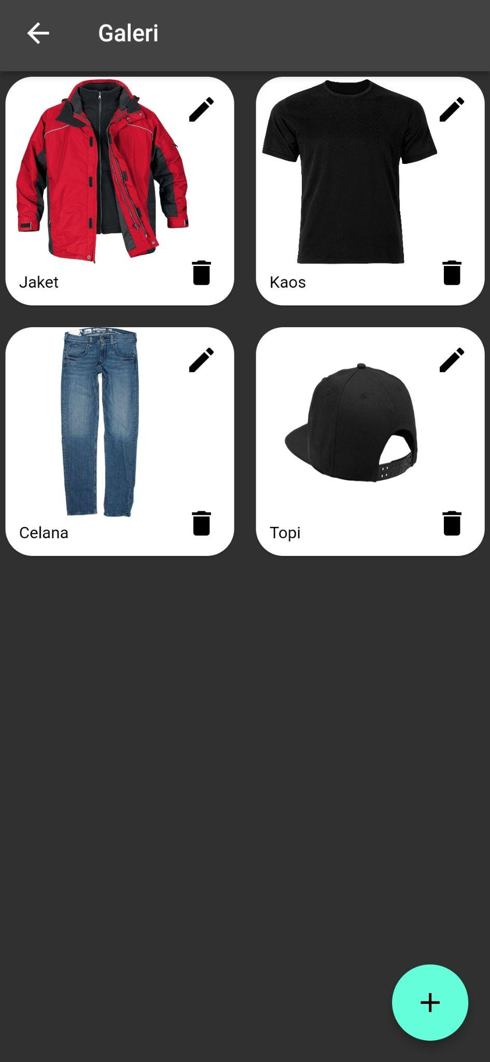

* Mengedit item galeri melalui provider. Disini saya mengedit image dari jaket, untuk mengedit item menggunakan icon edit yang ada di card item.
  + - Sebelum di edit



* + - Setelah di edit

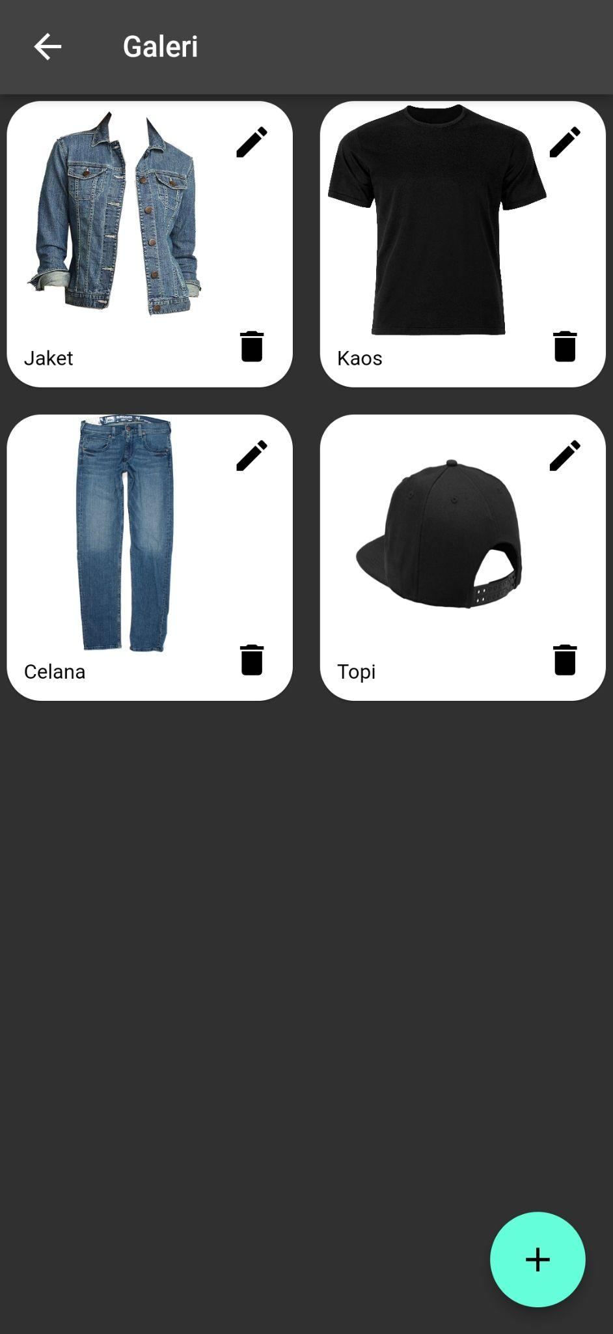

* Menghapus item melalui provider. Disini saya menghapus item kaos, untuk menghapus menggunakan icon delete yang ada di card item.
  + - Sebelum dihapus



* + - Setelah dihapus

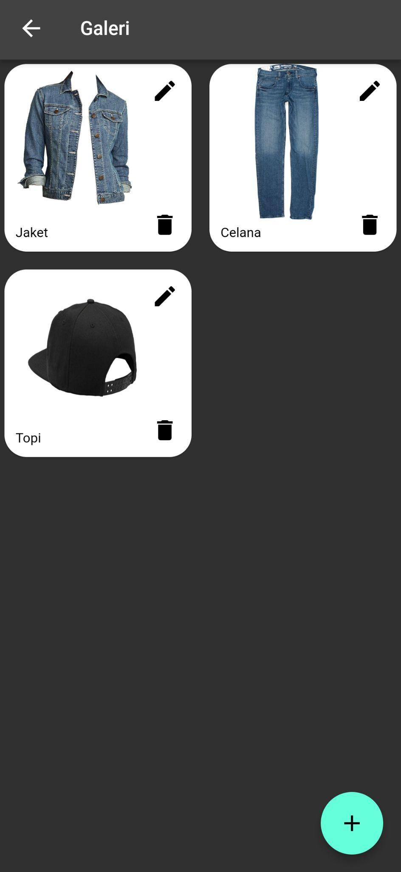

1. Tambahkan animasi sederhana pada salah satu fitur yang dibuat. (contoh: ketika pindah ke halaman tambah data kontak atau pada halaman galeri setiap gambar di tekan).

1). Flutter Code:

Disini saya menggunakan animasi Scale Transition.

* Main.dart

onGenerateRoute: (settings) {

final tween = Tween(begin: 0.0, end: 1.0);

switch (settings.name) {

case '/create_contacts':

return PageRouteBuilder(

settings: settings,

pageBuilder: (context, animation, secondaryAnimation) =>

const CreateContatcs(),

transitionsBuilder:

(context, animation, secondaryAnimation, child) =>

ScaleTransition(

scale: animation.drive(tween), child: child));

* Contacts.dart

onPressed: () {

Navigator.pushNamed(context, '/create_contacts');

},

child: const Text(

"Create Contacts",

style: TextStyle(

fontFamily: 'Roboto-Regular',

fontSize: 14,

),

* CreateContacts.dart

onPressed: () async {

await tambahContact();

namaController.text = "";

nomorController.text = "";

_fileName = null;

_filePath = "";

currentColor = Colors.blue;

Navigator.pop(context);

2). Output

